12:30-1:30 Reading the History of Landscapes in Illinois
Presenter: David Lehman, Doctoral Candidate, Department of History, University of Illinois, Urbana-Champaign

Why is Illinois so square? In this session we will look at historical documents related to the United States’ annexation of land and selective authorization of land ownership. We will discuss the Public Land Survey System, land treaties between factions of the Potawatomi Nation and the U.S., land patents, and local pioneer histories as well as their long-term effects.

1. Land ownership and sovereignty in the fledgling United States

A congress under the Articles of Confederation took over from the second continental congress in 1781. They eventually produced the U.S. constitution in 1789, but before the constitution came plans for westward expansion. The National Archives and Library of Congress provide images and a transcript, respectively, of the Land Ordinance of 1785, which was based on a 1784 proposal by Thomas Jefferson.

An ORDINANCE for ascertaining the Mode of disposing of LANDS in the WESTERN TERRITORY.
BE IT ORDAINED BY THE UNITED STATES IN CONGRESS ASSEMBLED,
THAT the territory ceded by individual states to the United States, which has been purchased of the Indian inhabitants, shall be disposed of in the following manner.---
A surveyor from each state shall be appointed by Congress or a Committee of the States, who shall take an oath for the faithful discharge of his duty, before the geographer of the United States, who is hereby empowered and directed to administer the same; and the like oath shall be administered to each chain carrier, by the surveyor under whom he acts.
[…]
The lines shall be measured with a chain; shall be plainly marked by chaps on the trees, and exactly described on a plat, whereon shall be noted by the surveyor, at their proper distances all mines, salt springs, salt licks and mill seats, that shall come to his knowledge, and all water courses, mountains, and other remarkable and permanent things, over or near which such lines shall pass, and also the quantity of the lands.
The plats of the townships respectively, shall be marked by subdivision into lots of one mile square, or 640 acres, in the same direction as the external lines, and numbered from 1 to 36. Always beginning the succeeding range of the lots with the number next to that with which the preceding one concluded. And where from the causes before mentioned, only a fractional part of a township shall be surveyed, the lots protracted thereon, shall bear the same numbers as if the townships had been entire. And the surveyors in running the external lines of the townships, shall at the interval of every mile, mark corners for the lots which are adjacent, always designating the same in a different manner from those of the townships.
[…]
There shall be reserved for the United States out of every township, the four lots, being numbered, 8, 11, 26, 29, and out of every fractional part of a township, so many lots of the same numbers as shall be found thereon. There shall be reserved the lot No. 16 of every township, for the maintenance of public schools within the said township. Also one third part of all gold, silver, lead and copper mines, to be sold, or otherwise disposed of, as Congress shall hereafter direct.
This system was intended to turn land the federal government knew next to nothing about into units it could sell. It required surveyors and their assistants to swear testimony that their measurements were not doctored. The government then recorded the sale of deeds in ledgers using only township, range, and section numbers as a “description” of the land in question.

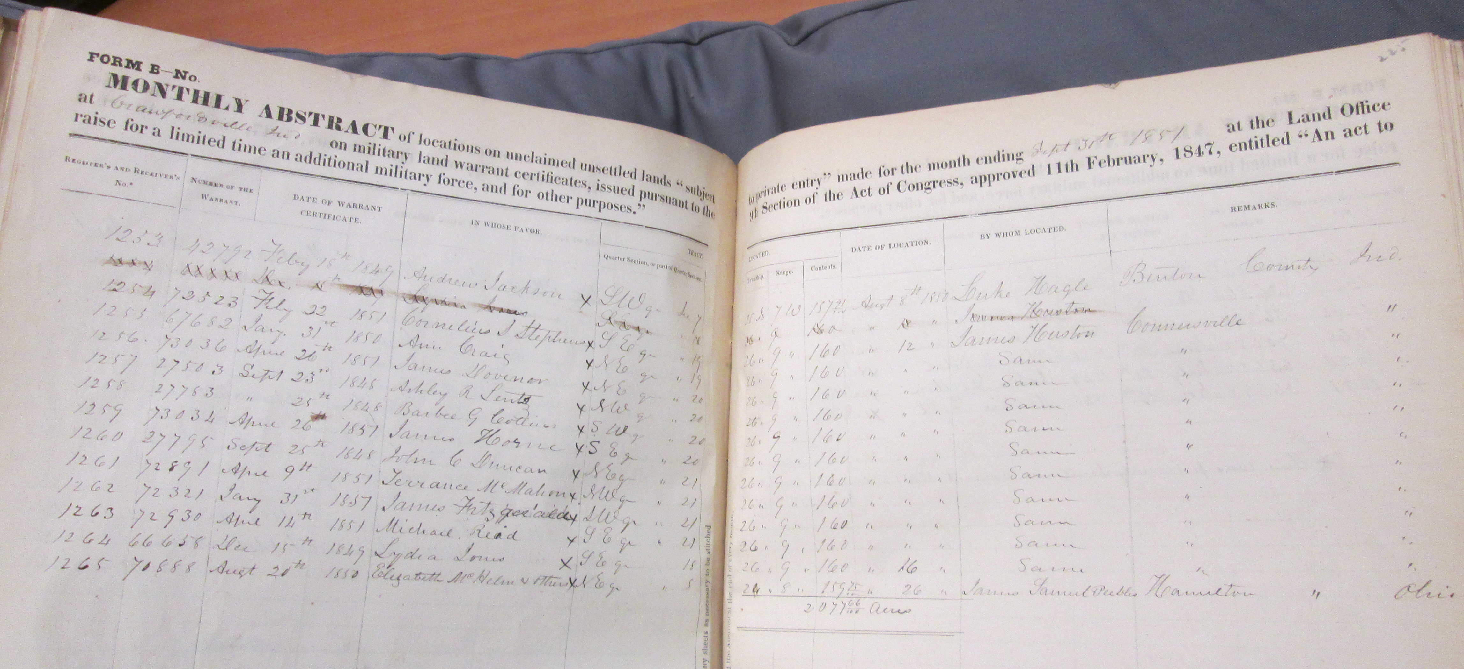

The only important thing to the U.S. federal government was that it was measured, and thus claimed. Then the government claimed the right to issue patents for the permanent ownership of that land once American Indians’ “right of occupancy” had been “extinguished” by land treaties. Land patents were signed by the president and paid for through a multi-layered bureaucracy of land offices.

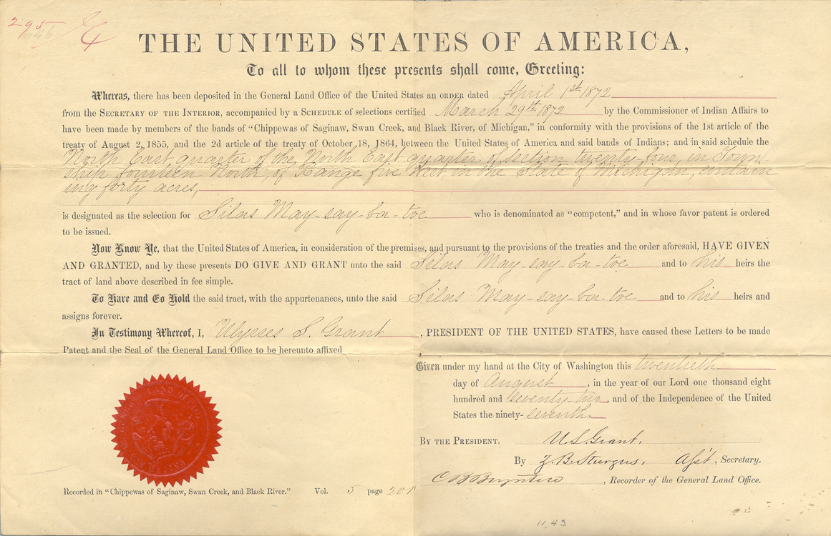
This land patent from 1872 still uses the form language established by the 1785 ordinance.

The Northwest Ordinance of 1787 followed the 1785 ordinance, providing a path for white settlers to organize new states in the union. It is also available online through the government’s “Our Documents” collection of images and transcripts. Below is an article related to making future treaties:

Article 3. Religion, morality, and knowledge, being necessary to good government and the happiness of mankind, schools and the means of education shall forever be encouraged. The utmost good faith shall always be observed towards the Indians; their lands and property shall never be taken from them without their consent; and, in their property, rights, and liberty, they shall never be invaded or disturbed, unless in just and lawful wars authorized by Congress; but laws founded in justice and humanity, shall from time to time be made for preventing wrongs being done to them, and for preserving peace and friendship with them.

Questions
- Why was measuring land so important to the newly United States?
- What common goals did they find on which to base their plan for collective westward expansion?
- What problems can you predict would arise from these plans?

2. The visibility of the Public Land Survey System today

The diagram below illustrates the method for numbering the 36 sections within a surveyed township, (which can differ from municipal townships in their boundaries). In the minds of framers like Thomas Jefferson, a utopian republic was possible by turning what they saw as blank space into locally governed townships with their own schools where each family farm covered one eighth section, or 80 acres. In practice, townships did not fit together so neatly in many landscapes. Rivers, mountains, lakes, older French plots, American Indian reservations, surveyors’ errors, and land designated for certain roads and canals interrupted the “ideal” plan for U.S. expansion. Settlers did not invade new lands in a uniform manner, either, picking out specific environments as in this example from Northern Indiana.

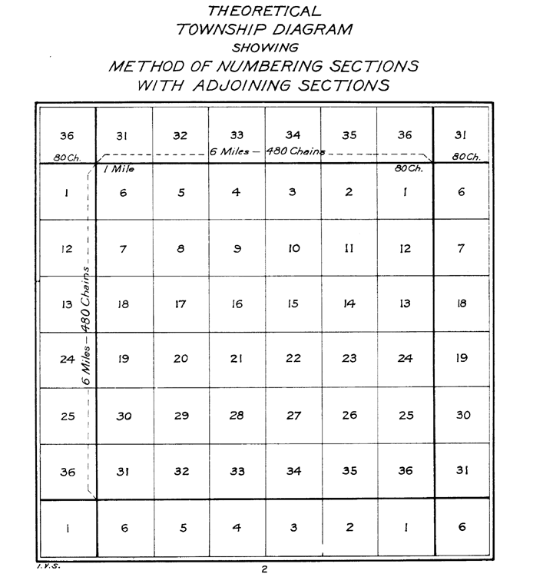

The image below is a satellite view of Township 17 North Range 6 East of the 3rd Principle Meridian. The boundaries 36 square sections of the township are visible among the fields as well as rectangular subdivisions of those sections. The diagonal line is a stretch of the Illinois Central Railroad between Ivesdale and Bement, Illinois. Other non-square lines include streams among the headwaters of the Kaskaskia River now transformed into drainage ditches.

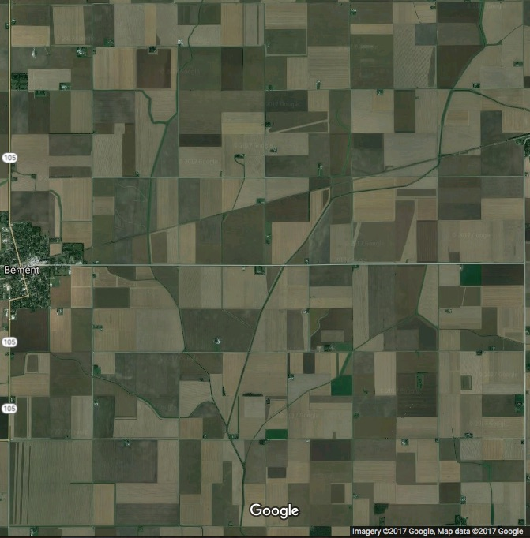

Questions
- Which parts of the landscape did or did not conform to the grid? Why?
- Why is this township not full of independent landowners and their families who go to one local school and vote in one local assembly as Jefferson envisioned?

3. “Firsting and Lasting” in Aurora, Illinois

One way to understand more about the United States is to apply the term “settler colonialism” to our society. This terms point to the American Indian viewpoint that the “colonial period” of U.S. history never ended. The invading claims of supreme sovereignty changed hands from an occupying overseas government to an occupying neighboring government, but the invaders never left nor did they stop taking land.

“Firsting and Lasting,” a book by Jean M. O’Brien, names a significant pattern in settlers’ accounts of pioneer history. Local histories sought to establish the first “permanent” settlers and portray Native people as mobile transients who disappeared in a final manner, even as people of American Indian descent still lived in the area. One illustration of this is to contrast the enduring popularity of the book “The Last of the Mohicans” with the still-extant Mohegan Nation. Below is an excerpt from a local pioneer history that illustrates this goal of many settler histories.

1834: Samuel McCarty's description of Wabaunsee's village
Samuel McCarty is known as the founder of Aurora, but a village already existed when he arrived there in November of 1834. Mr. McCarty recalled, "It was not a wild, desolate, unpopulated region . . .
. . . for we had plenty of neighbors in the red men, who had occupied and enjoyed these beautiful prairies and rivers for many and many a year before this, and the village of the head war chief of the Pottawattomie nation was but little over a mile north of us. On the west side of the river, on the bluff opposite Mr. Tanner's stone farm house, and a little north, was the Indian burying ground, a part of which is now occupied by the Catholics for the same purpose. The village and vicinity contained from three hundred to five hundred Indians, and we had many visits from them. Quite a commercial trade sprang up between us, especially swapping bread and tobacco for fish, of which we soon found that they had much the largest supply, although we could give but one slice for a large fish weighing from three to five pounds, and then at times they would have several in their canoes to take back.
. . . The old chief, Waubonsie, • was a large and powerful man . . . . The most of their village was composed of movable or temporary wigwams, as the tribe was a wandering and unsettled people. They spent their summers here on Fox River, but would emigrate to the south to spend the winter on the Illinois and Kankakee, returning in the spring. The old chiefs wigwam, being the capitol of the tribe, was built very substantially, apparently to stand for centuries, the posts and frames being of red cedar. . . . The building, I think, was about twenty feet wide by thirty feet long . . .. . .. The outside of this capitol was covered with the bark of the linn or basswood tree, taken from the standing trees, fitted to the sides and roof of the building very nice and tight. It was fastened by cutting three-cornered holes through the bark, and tying to the cross rafters with the inside bark of young basswood trees. (35)
Seats or beds along either side of a main hallway were built of girders and smaller poles, on which was placed "wide bark taken from the basswood tree":
These were covered with the skins of the animals they had slain, such as wolves, lynx, wildcats, and deer. Thus were formed their beds, with Government blankets or buffalo skins for covering. (35)

• Samuel McCarty spelled the Potawatomi chiefs name Waubonsie. Ellen Whitney, a scholar of the Black Hawk War, selected Waubansee as the preferred spelling. The stream that joins the Fox River at Oswego has yet a different spelling: Wabaunsee Creek.

Excerpted from:

Beers, Leggett & Co. 1888. Commemorative Biographical and Historical Record of Kane
County, Illinois. Chicago.

In:

White, John. Ecological Services, “Fox River Area Assessment Volume 5: Early
Accounts of the Ecology of the Fox River Area” (Critical Trends Asessment
Program, October 2000).

Questions
- How does McCarty describe the Potawatomi land he moved on to?
- How does he describe Potawatomi use of that land?
- How does he describe relationships with the Potawatomi as neighbors?
- How does McCarty’s “pioneer” account pave the way for local historical narratives that follow the “firsting and lasting” pattern?
- How do you think Waubonsie would have described McCarty?

4. Land Treaties

The National Museum of the American Indian’s current exhibit on treaties, “Nation to Nation,” offers some good videos, photos, and other resources for learning about the history of treaties between the U.S. and various American Indian nations. An 1838 treaty

“extinguish” Indian title

The “Trail of Death” (see pictures on the next page)

“Members of the Council: The President does not know the truth. He, like me, has been imposed upon. He does not know that you made my young chiefs drunk and got their consent and pretended to get mine. He does not know that I have refused to sell my lands, and still refuse. He would not drive me from my home and the graves of my tribe, and my children, who have gone to the Great Spirit, nor allow you to tell me your braves will take me, tied like a dog, if he knew the truth. My brother, the President is just, but he listens to the word of young chiefs who have lied; and when he knows the truth, he will leave me to my own. I have not sold my lands. I will not sell them. I have not signed any treaty, and will not sign any. I am not going to leave my lands, and I do not want to hear anything more about it.”

Daniel McDonald, A Twentieth Century History of Marshall County, Indiana (Chicago, Lewis Publishing Co., 1908) http://hdl.handle.net/2027/inu.32000007471982

This is available through Hathi Trust, an online repository for digitized historical documents.
Questions

- What does Menominee say clearly about U.S. invasion of his home?
- What does he imply about the practices of U.S. expansion?
- What does this speech, its recording, and its recounting teach us about U.S. and Potawatomi histories?
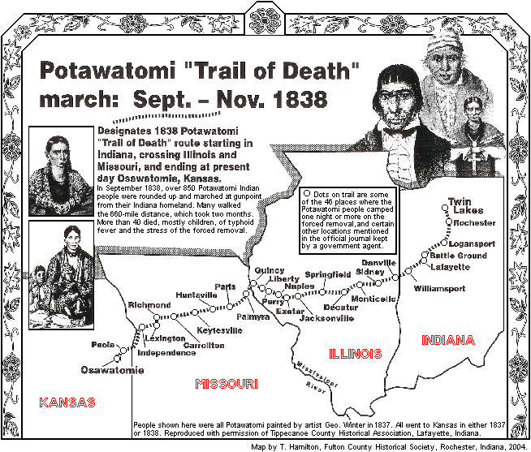
http://www.potawatomi-tda.org/
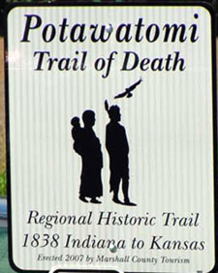
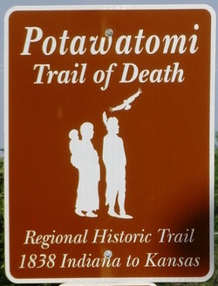

5. The legacies of inequality in land ownership

Below is a transcript of and link to video for a one-minute speech Martin Luther King Jr. gave as a member of the Poor People’s Campaign to a classroom about U.S. history and land policies since reconstruction. He refers to the failure of reconstruction to effectively change economics in the United States by leaving old land titles intact in the south while opening land in the west to white pioneers through the 1862 Homestead Act and providing funding for universities through the Morrill Land-Grant Act.
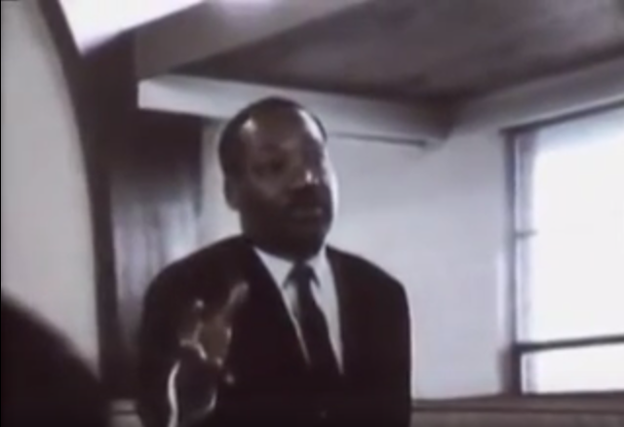
https://www.youtube.com/watch?v=CSLXgsvBu3U
MARTIN LUTHER KING, Jr: [1968] At the very same time that America refused to give the Negro [sic] any land, through an act of Congress our government was giving away millions of acres of land in the West and the Midwest, which meant that it was willing to undergird its white peasants from Europe with an economic floor.
But not only did they give the land, they built land grant colleges with government money to teach them how to farm. Not only that, they provided county agents to further their expertise in farming. Not only that, they provided low interest rates in order that they could mechanize their farms.
Not only that, today many of these people are receiving millions of dollars in federal subsidies not to farm, and they are the very people telling the black man that he ought to lift himself by his own bootstraps. And this is what we are faced with, and this is the reality. Now, when we come to Washington in this campaign, we are coming to get our check.
Questions

- What insights can you gain from King’s summary about U.S. history and about the 1968 Poor People’s Campaign?
- What do you think King’s summary leave out?

