T.E. Musselman, “A History of the Birds of Illinois,” Journal of the Illinois State Historical Society 14 (April 1921 to Jan. 1922): 1-73.

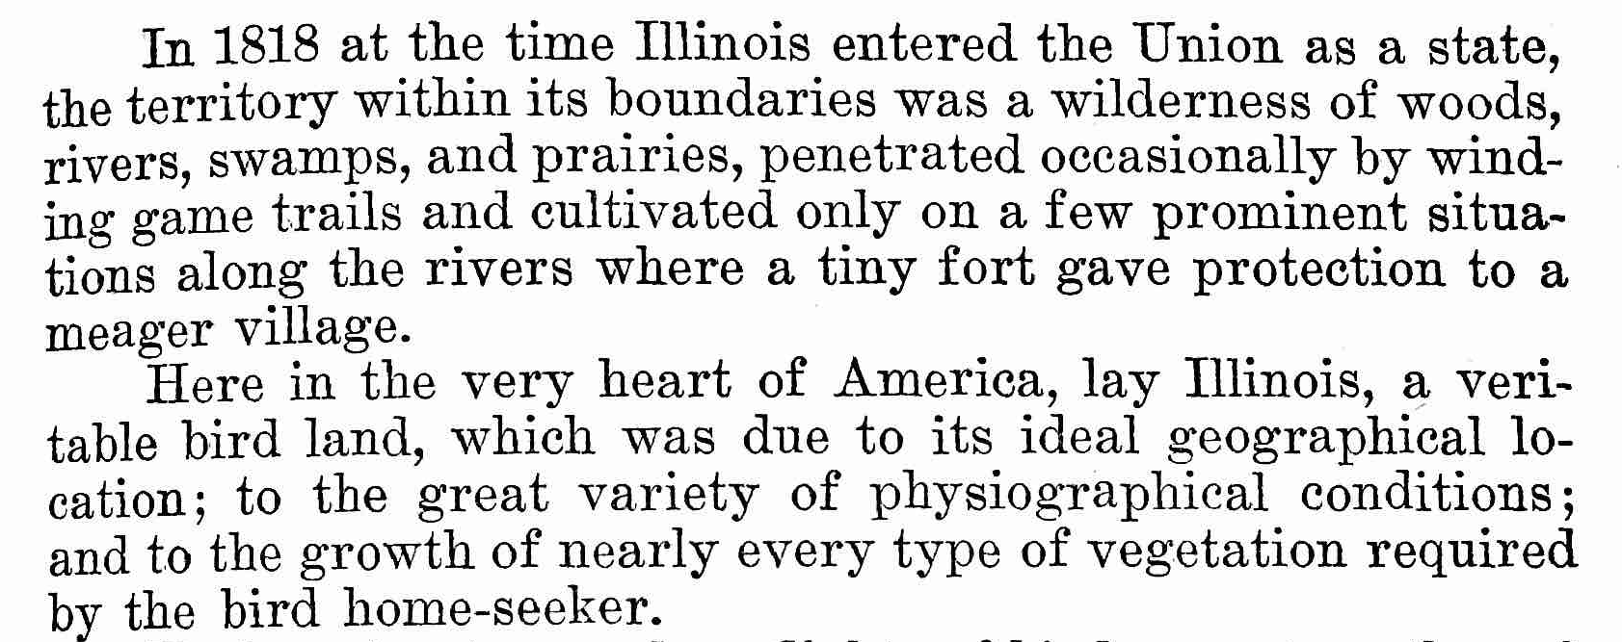…
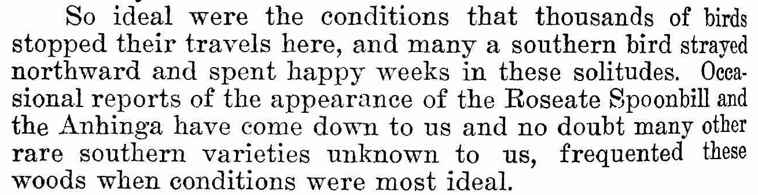
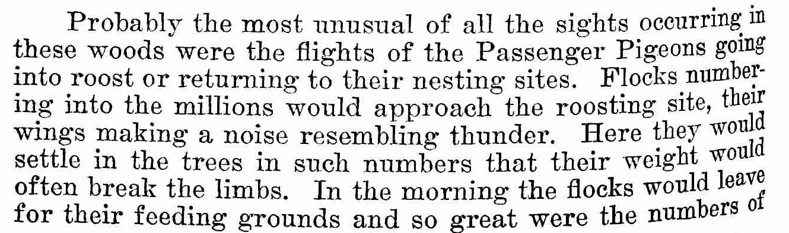
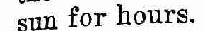
… The following interesting account of


