William T. Hornaday, “Chapter II: Extinct Species of North American Birds,” in Our Vanishing Wild Life: Its Extermination and Preservation (New York: New York Zoological Society, 1913). (Hornaday was the director of the New York Zoological Park and ex-president of The American Bison Society.)
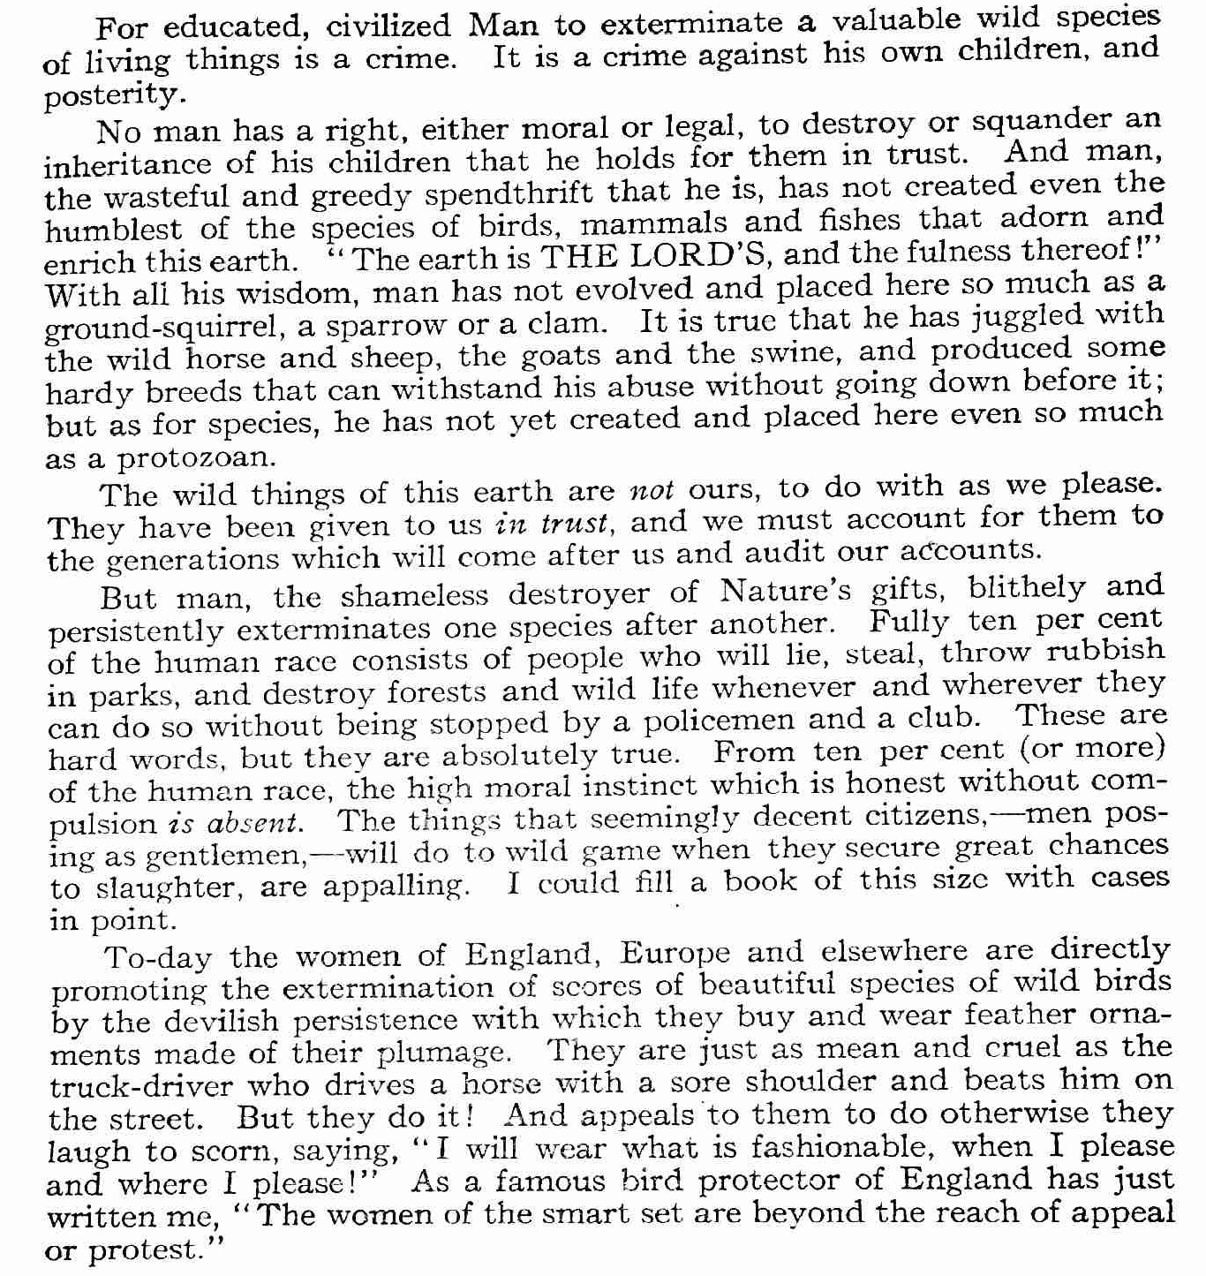
To-day, the thing that stares me in the face every waking hour, like a grisly specter with bloody fang and claw, is the extermination of species. To me, that is a horrible thing. It is wholesale murder, no less. It is capital crime, and a black disgrace to the races of civilized mankind. I say “civilized mankind,” because savages don’t do it!
…
The chapter goes on to list and describe extinct species of American birds, including the Great Auk, Labrador Duck, Pallas Cormorant, and Passenger Pigeon.

The next chapter is titled “Bird Tragedy on Laysan Island.”

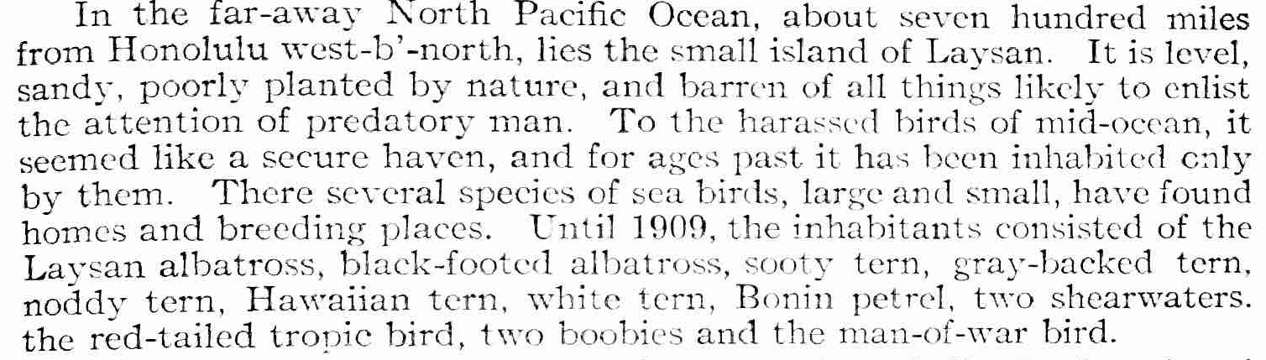

Ever since 1891 the bird life on Laysan has been regarded as one of the wonders of the bird world. One of the photographs taken prior to 1909 shows a vast plain, apparently a square mile in area, covered and crowded with Laysan albatrosses. They stand there on the level sand, serene, bulky and immaculate. Thousands of birds appear in one view—a very remarkable sight.
Naturally man, the ever-greedy, began to cast about for ways by which to convert some product of that feathered host into money. At first guano and eggs were collected. A tramway was laid down and small box-cars were introduced, in which the collected material was piled and pushed down to the parking place.
For several years this went on, and the birds themselves were not molested. At last, howver, a tentacle of the feather-trade octopus reached out to Laysan. In an evil moment in the spring of 1909, a predatory individual of Honolulu and elsewhere, name Max Schlemmer, decided that the wings of those albatross, gulls and terns should be torn off and sent to Japan, whence they would undoubtedly be shipped to
Paris, the special market for the wings of sea-birds slaughtered in the North Pacific.
Schlemmer the Slaughterer bought a cheap vessel, hired twenty-three phlegmatic and cold-blooded Japanese laborers, and organized a raid on Laysan. With the utmost secrecy he sailed from Honolulu, landed his bird-killers upon the sea-bird wonderland, and turned them loose upon the birds.
For several months they slaughtered diligently and without mercy. Apparently it was ambition of Schlemmer to kill bird on the island.
By the time the bird-butchers had accumulated between three and four car-loads of wings, and the carnage was half finished, William A. Bryan, Professor of Zoology in the college of Honolulu, heard of it and promptly wired the United States Government.
Without the loss of a moment the Secretary of the Navy despatched the revenue cutter Thetis to the shambles of Laysan. When Captain Jacobs arrived he found that in round numbers about three hundred thousand birds had been destroyed, and all that remained of them were several acres of bones and dead bodies, and about three carloads of wings, feathers, and skins. It was evident that Schlemmer’s intention was to kill all the birds on the island, and only the timely arrival of the Thetis also brought away all the stolen wings and plumage with the exception of one shedful of wings that had to be left behind on account of lack of carrying space. That old shed, with one end torn out, and supposed to contain nearly fifty thousand pairs of wings, was photographed by Professor Dill in 1911, as shown herewith.
Three hundred thousand albatrosses, gulls, terns and other birds were butchered to make a Schlemmer holiday! Had the arrival of the Thetis been delayed, it is reasonably certain that every bird on Laysan would have been killed to satisfy the wolfish rapacity of one money-grubbing white man.
[the article cites a professor, Homer R. Dill, sent by Iowa State University to investigate.
“An old cistern back of one of the buildings tells a story of cruelty that surpasses anything else done by these heartless, sanguinary pirates, not excepting the practice of cutting wings from the living birds and leaving them to die of hemorrhage. In this dry cistern the living birds were kept by hundreds to slowly starve to death. In this way the fatty tissue lying next to the skin was used up and the skin was left quite free from grease, so that it required little or no cleaning during preparation.
