“Pigeon Slaughter” in The Passenger Pigeon By Prof. H. B. Roney, East Saginaw, Mich. Originally published in the journal American Field.

“The Passenger Pigeon”

“The number of pigeons caught in a day by an expert trapper will seem incredible to one who has not witnessed the operation. A fair average is sixty to ninety dozen birds per day per net and some trappers will not spring a net upon less than ten dozen birds. Higher figures than these are often reached, as in the case of one trapper who caught and delivered 2,000 dozen pigeons in ten days, being 200 dozen, or about 2,500 birds per day. A double net has been known to catch as high as 1,332 birds at a single throw…

The prices of dead birds range from thirty-five cents to forty cents per dozen at the nesting. In Chicago markets fifty to sixty cents. Squabs twelve cents per dozen in the woods, in metropolitan markets sixty cents to seventy cents. In fashionable restaurants they are served as a delicious tid-bit at fancy prices. Live birds are worth at the trapper’s net forty cents to sixty cents per dozen; in cities $1 to $2. It can thus be easily seen that the business, when at all successful, is a very profitable one, for from the above quotations a pencil will quickly figure out an income of $10 to $40 per day for the “poor and hard-working pigeon trapper.” One “pigeoner” at the Petoskey nesting was reported to be worth $60,000, all made in that business. He must have slain at least three million pigeons to gain this amount of money.
…
[The text describes the author’s arrival at a pigeon nesting just north of Petoskey, Michigan the previous year.]

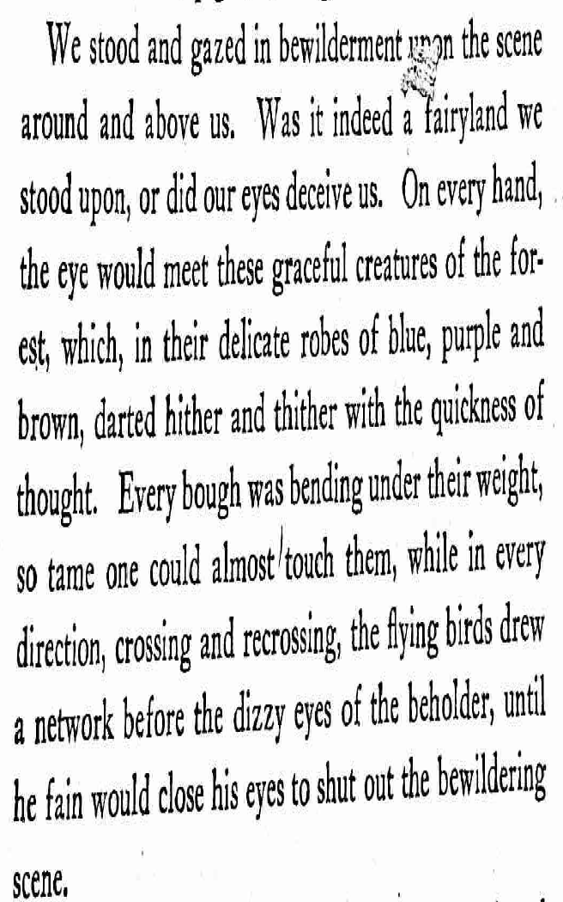
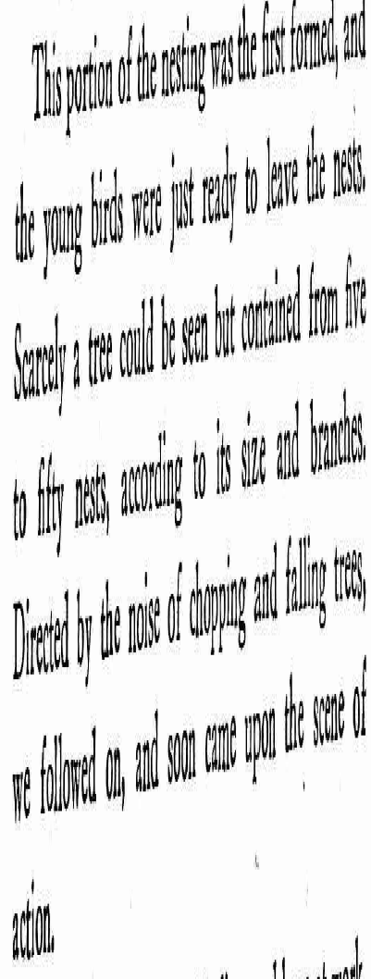

Here was a large force of Indians and boys at work, slashing down the timber and seizing the young birds as they fluttered from the nest. As soon as caught, the

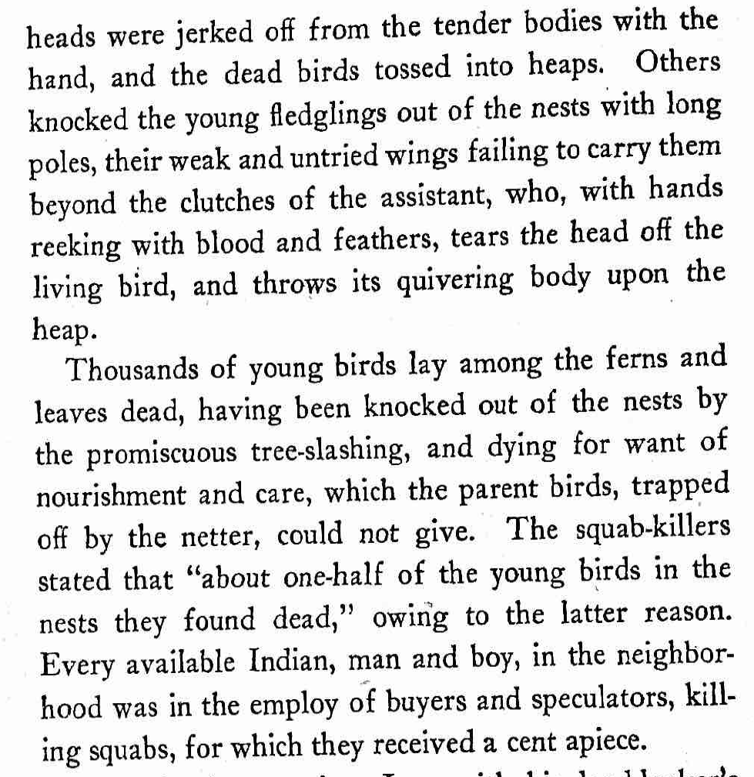…
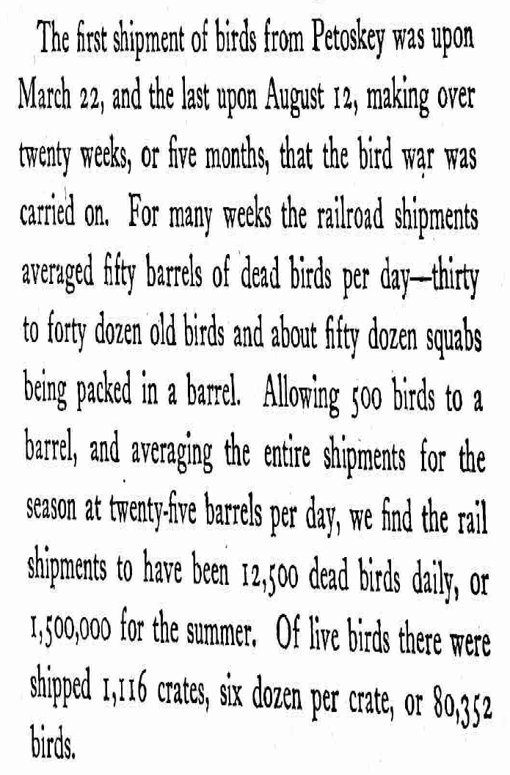

[The author estimates that if birds shipped by steamer and wagon were counted, along with the birds left behind and the babies left to starve in the nest, the total would reach a billion pigeons “sacrificed to Mammon during the nesting of 1878.”]

