“The Pigeon Butcher’s Defense,” originally published in the hunting magazine, American Field on Jan. 25, 1879, and reprinted in The Passenger Pigeon By Prof. H. B. Roney, East Saginaw, Michigan.

The introduction identifies Martin as “a game dealer of Chicago” and “also a dealer in guns, glass balls, traps, nets, etc.” The introduction also refutes Martin’s estimate that 89,730 live pigeons were shipped from Cheboygan, by citing the records of a Detroit shipper who alone shipped 175,000 from that city. The Emmett County noted in the piece is a county in northern Michigan.

… This whole pigeon trade was a perfect Godsend to a large portion of Emmett County. The land outside of Petoskey is taken up by homesteaders, who, between clearing their land, scanty crops, poor soil, large families, and small capital, are poorer than Job’s turkey’s prodigal son and in years past have had all they could do fighting famine and cold, and but a year or so since all Michigan was sending relief to keep them from starving, thousans of dollars being contributed, and then most harrowing tales being told of need and destitution.

The “pirates and bummers” left some $35,000 in good greenbacks right among the most needy of these people. Many were enabled to buy a team, others to clear more land, more to increase their crops, and all to lay in provisions and clothing to meet the bitter winter we are now passing through, and this money did more to open up Emmett County than years of ordinary work. It put scores of honest, hard-working homesteaders on their feet; it increased trade, and, if sent by a special acto fo Providence, could not have done more good. …

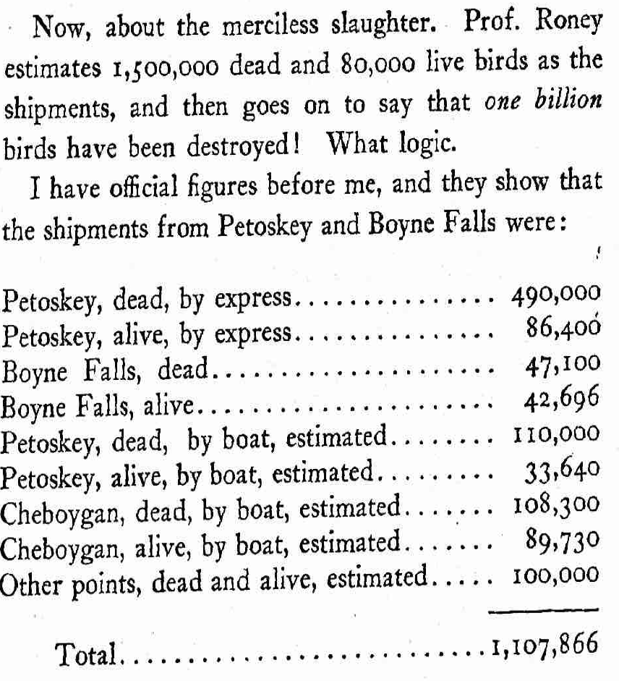…

I doubt if there were a billion birds in all the … nestings. I am certain that there were not at any one time. I am also certain that more than double as many young birds left those nestings than all the birds caught, killed or destroyed. …

I don’t believe Prof. Roney knows what a billion is. However, there were not 750,000, no, nor 100,000 squabs killed by losing their parents. It is a well-proved fact that the old bird coming in will stop and feed any squab heard crying for food, that in this way they look out for one another’s young, and the orphans or half-orphans are cared for. It is rare, however, for both old birds to be caught or killed, since the toms and hens when nesting always fly separately, and the chance of both the parents of the squab falling a “victim to Mammon,” particularly in a large nesting, is small. As proof of the pigeons feeding squabs indiscriminately, I may mention that one nof the men in my employ this year, at the Shelby nesting in 1876, in one afternoon shot and killed six hen pigeons that came to feed the one squab in the same nest.
…

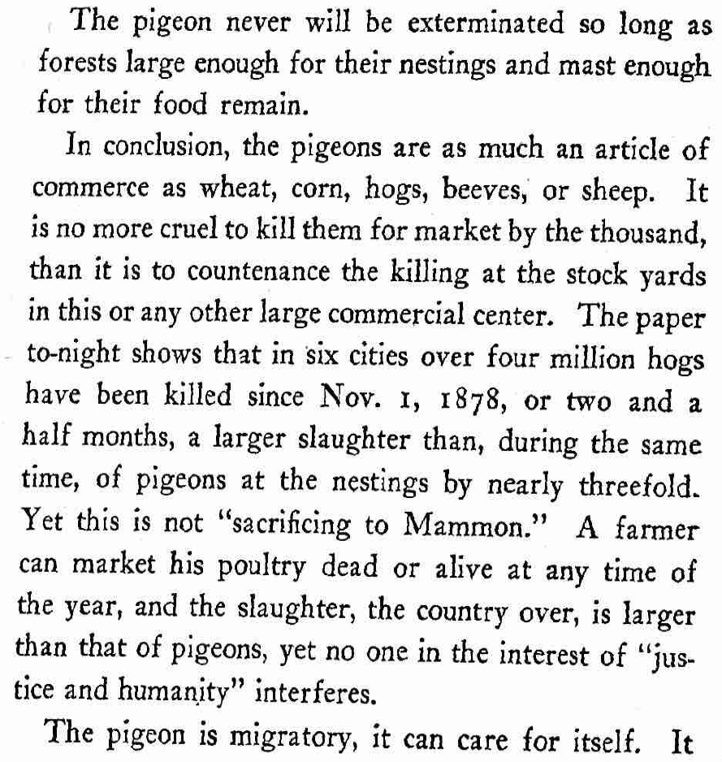…

Let the law, in regard to distance, stand as it is. Enforce it against all alike; make no exceptions; let the rule of supply and demand govern the catchings, and you will have something better than all the professors in Michigan suggest. Let the supply be so large that prices are low and wages can’t be made, and law or no law, the catching will stop. But don’t’ make a law that will take bread out of the homesteader’s mouth, and work from hundreds of poor honest men; no, not even if the birds should be sacrificed, to a certain extent, for man is above the bests, and the “beasts of the field and the birds of the air” are given unto him for his benefit and his profit.

